**

**The Superior University**

**📝 Operating Systems Lab – Project Documentation Template**

**📌 Project Title**

*CPU Scheduling Simulator in PYTHON*

**👥 Group Members**

* Ahsan Ullah-222
* Muhammad Umair-200
* Waleed khan-218
* Ali Hussnain-067

**📂 GitHub Repository**

**GitHub Repository Link:**

https://github.com/muhammadahsaanullah/CPU-Scheduling-simulator.git

**🔧 Scheduling Algorithm Implemented**

✅ Tick the scheduling algorithm your group implemented:

* ✅FCFS (First Come First Serve)
* SJF (Shortest Job First – Non-Preemptive)
* SJF (Preemptive)
* Round Robin

**📄 Project Description**

Briefly explain:

* This project simulates how a CPU schedules tasks using the First-Come-First-Serve (FCFS) algorithm. It helps visualize and calculate how processes are handled over time, optimizing resource planning and performance analysis.
* **Inputs:** Arrival Time and Burst Time for each process.
* **Outputs:** Start Time, Completion Time, Turnaround Time, Waiting Time, Average TAT and WT.
* **Implementation:** Processes are sorted by arrival time and executed in that order, with each process's times calculated sequentially.

**📸 Output Screenshots**

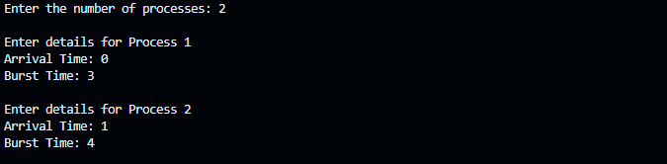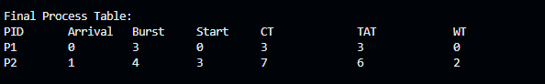

**🧠 Code Structure & Explanation**

* **Code Organization:** The code is organized using functions (fcfsScheduling, printResults, printGanttChart, and main) for modularity and clarity.
* **Core Logic:** The fcfsScheduling function sorts processes by arrival time and calculates start, completion, turnaround, and waiting times sequentially.

**🛠️ Challenges Faced**

**1. Incorrect Waiting Time Calculation:** Initially, we miscalculated waiting time by not considering idle CPU time; we fixed it by ensuring current_time jumps to the process's arrival time if the CPU is idle.

**3. Sorting Logic Bug:** Some processes were executed out of order due to not sorting by arrival time; we added a custom comparator to sort the process list before scheduling.c.